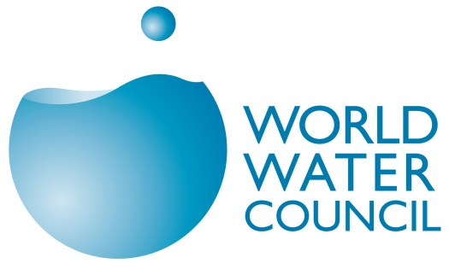 | World Water Council  Membership Application Form

Identification
Name of your organisation:
Acronym / abbreviation: Department / Unit:
Date of Establishment:
Country of establishment:
Organisation’s profile
- What is your annual budget?
- What are your main sources of income?
- How many employees do you have?
- Are you a membership organisation, if so, how many members do you have?
Is it international membership? Yes/ No
Do you have individual members, corporate members or both?
- Do you have subsidiary offices, and if so, how many?
If you do have subsidiary offices abroad, please indicate the countries in which your subsidiary office(s) are located?
Organisation’s activities
- Are your organization’s activities primarily focused on water?
Yes / No
Please indicate your field(s) of expertise and activities?
Water Resources Management  Water Supply and/or Sanitation  Regulation and/or Governance  Economics and/or Finance  Climate and Natural Hazards  Research and/or Assessment  Environment and/or Ecosystems  Media and/or Awareness  Energy and/or Industry | Education and/or Capacity Building  Human Settlements and/or Habitat  Human Rights and/or Social Issues  Agriculture and/or Beverage-Food Production  Development and/or Infrastructure  Human Basic Needs and/or Health  Technology and/or Engineering  International Cooperation and/or Humanitarian Relief  Other: …
Please specify your activities by providing a list of more precise keywords:

- Scope of your organization: International Multi-national Regional National Local Basin
Please indicate your geographical area(s) of expertise and/or activities?
Please provide a description of your activities linked to water (use a separate sheet if you need more space):

Address
Department / Unit:
Street: P.O. Box #: City:
Postal Code: Province/State: Country:
Telephone: Country code: Number: Facsimile:
Organization E-mail:
Website of your organisation: http://
Social media accounts:

Contacts
Official contact: Person responsible for the relationship with the WWC:
(Mr./Mrs.) First Name: Last Name: Position / Title:
E-mail: Other e-mail (while travelling or else):
President, CEO or equivalent: (Mr./Mrs.) First Name: Last Name:
Position / Title: E-mail:
Administrative contact: (Mr./Mrs) First Name: Last Name:
Position / Title: E-mail:
Communication contact: (Mr./Mrs.) First Name: Last Name:
Position / Title: E-mail:

Motivation and commitment
- Why is your organisation interested in joining the WWC?

- How do you intend to contribute to the mission and goals of the WWC?

We hereby confirm:
having read and understood the Constitution, By-Laws and Membership Guidelines of the World Water Council;
our commitment to paying the annual WWC membership fees; and
our acceptance to have our membership information and official contact published in the WWC directory.

Date: Stamp of the organization:
Name and signature of the CEO, President or equivalent:

- Additional information and clarification may be requested to support your application
- Your application will be reviewed by the WWC Bureau and submited to the WWC Board of Governors for final approval
- Upon adoption, you will receive a notification and an invoice for your membership fees
- Applicants are considered to be officially members subject to the payment of their membership fees

Please return the original of this form, duly filled in and signed, along with a brochure, an activity report and any additional documents you may feel relevant to your application to:
World Water Council, Conseil Mondial de l'eau
Espace Gaymard, 2-4 Place D’Arvieux,
13002 Marseille – France

For our record:
How did you hear about the World Water Council?
By attending a World Water Forum | By subscribing to the Water Policy Journal
By visiting the Council’s website | By meeting a World Water Council member
By receiving a Council’s communications | By meeting a HQ staff person
By attending an event of the Council | By receiving the membership package  Other:

